# **Tele-Health**

# **Problem Statement:**

Patients must visit to hospital and make an appointment with doctor, this process takes time and requires manual effort. Patient does not have a physical copy of the appointment while making appointment via mobile and there is no visual evidence that the appointment is confirmed. In today's health industry, especially during the pandemic the need of the virtual consultation and appointments have been increased. As a result, an application where the patient can book an appointment virtually or in person and interact with the doctor is needed. ***Tele-Health*** application is an online doctor consultation portal. The system streamlines the tele health care for both to providers and the users as well as reducing outpatients visits to hospital.

# **Scope and list of features on the proposed application**

Scope of the application is Admin, Doctor and Patient portal with the below listed features

## **Administrator**

* Admin Login.
* Admin verifies and accepts the providers that want to consult.

## **Provider**

* (Doctor) Login.
* Updating the available slots for virtual and in person consultation.
* Accepts or Rejects the Appointment.

## **Patient**

* User Registration.
* User Login.
* User navigates through list of providers.
* User books the appointment.
* User selects mode of payment, mode of consultation and completes the transaction.
* On successful payment, user can track his appointment, whether it accepted with the confirmed details.

## **Tool Specifications**

|  |  |
| --- | --- |
| Operating Systems | Windows XP, Windows 7. |
| Languages/Technology | Core Java, GUI |
| RDBMS | My SQL |
| Development Tools/IDEs | NetBeans, Eclipse |

**Team Members**

Harika Bhemidi

Rakesh Janapureddy

Design Patterns

1. Strategy
2. Observer
3. Decorator

Strategy Pattern

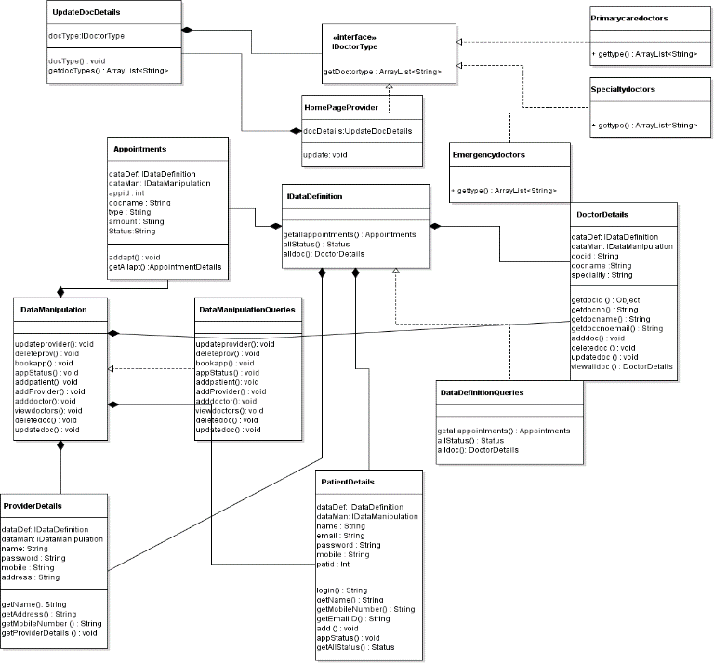

Observer

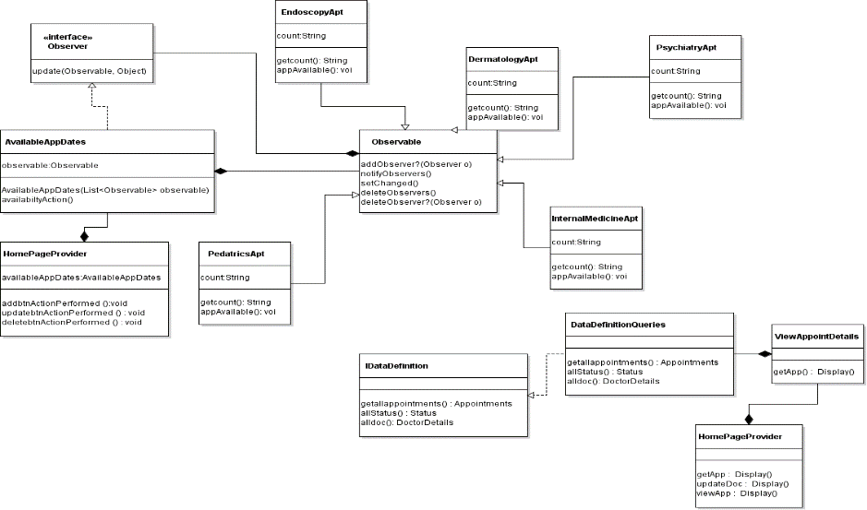

Decorator

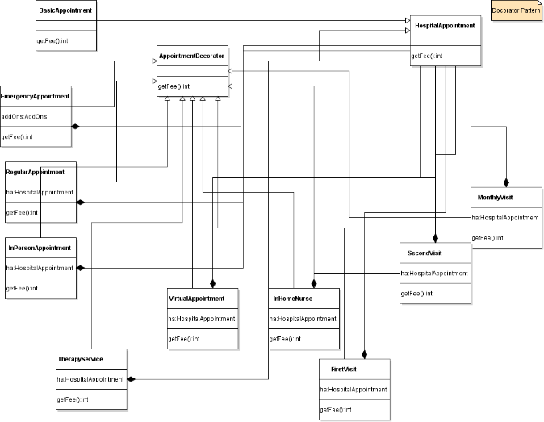

Class Diagram

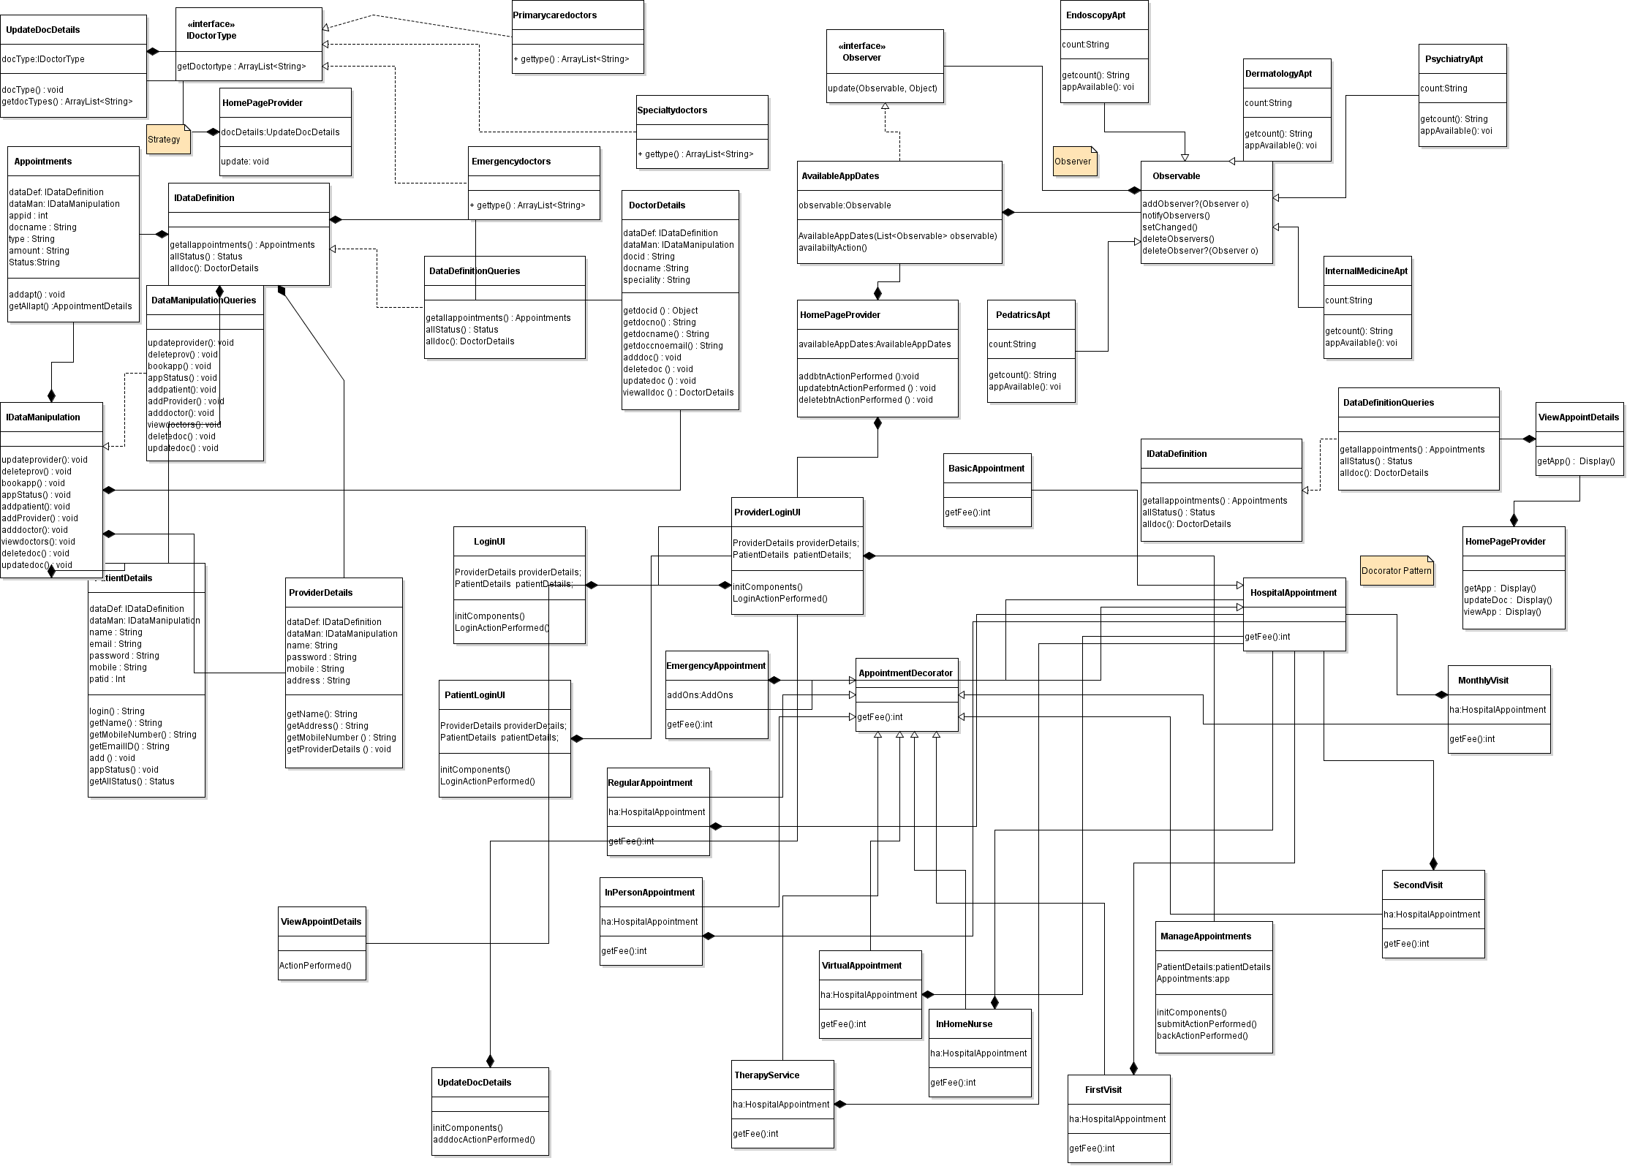

UI Screen Shots

Admin Login Page

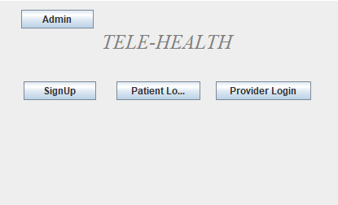

Login Page

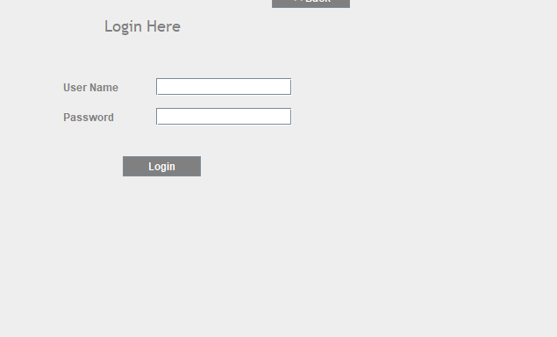

User Page

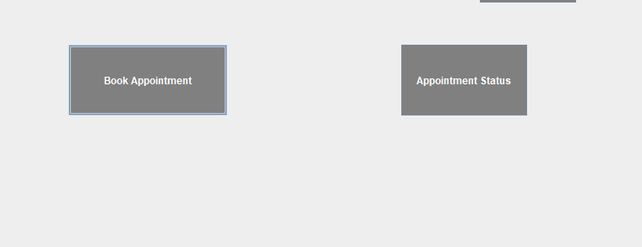

Appointment Booking

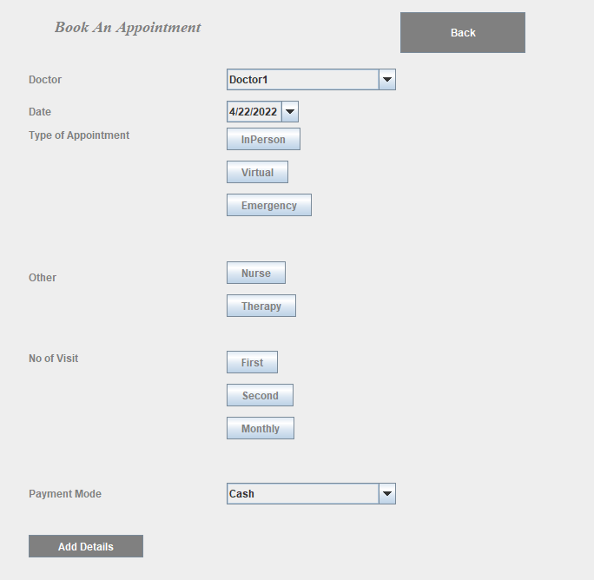

Appointment Status

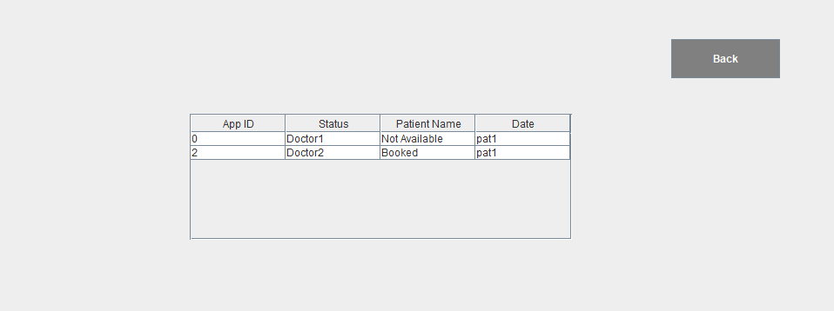

Provider Login

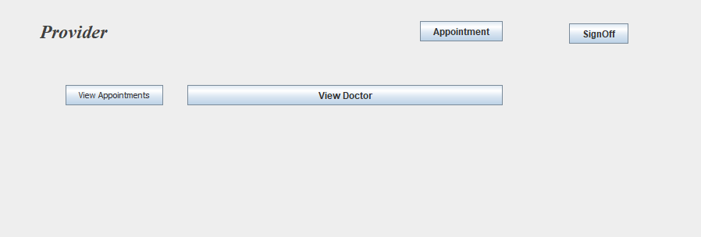

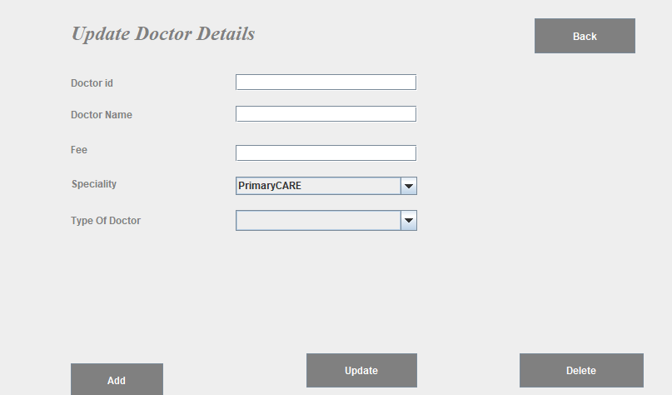

Available Apt

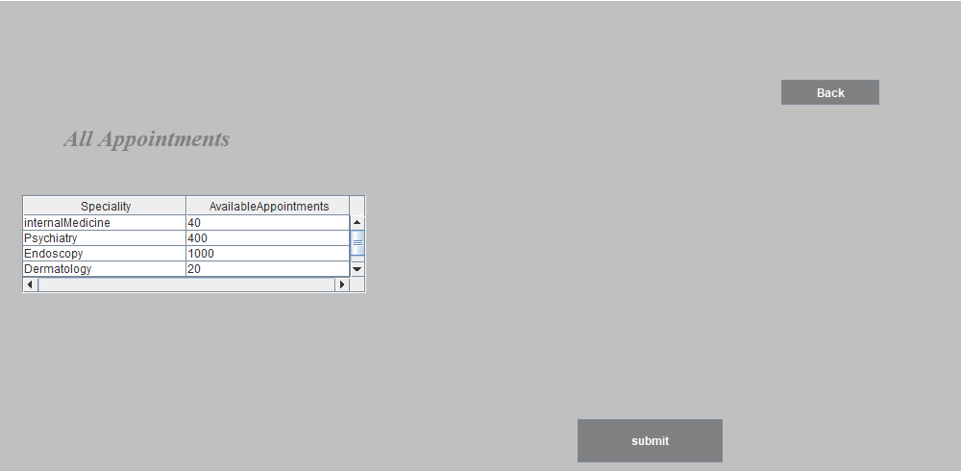

Provider Appointments

